**Edge Preservation based CT Image denoising in Wavelet domain**

Hiten Panwar1, Neha Gupta2

1,2Department of Computer Science and Engineering

1,2Graphic Era Deemed to be University, Dehradun

India

1[hitenpanwar2@gmail.com](mailto:hitenpanwar2@gmail.com), 2[nehagpt692@gmail.com](mailto:nehagpt692@gmail.com)

**Abstract:**

Computed Tomography (CT) is majorly the vital appliances to identify the nature of any illness or disease in Medical Science. The nature of CT images is based on X-ray amount. If the X-ray draught is larger, the nature of the CT images is comparatively finer but it might cause worse consequences to the patients. Less draught CT images are noisy because of the vital cause, for example, Statistical Uncertainty in all the physical measurements. If the noise could be suppressed or decreased from low draught CT images, then the nature of low draught CT images can be upgraded without enlarging the draught. Therefore, this paper includes a technique called bilateral filter and wavelet packet-based thresholding are extracted. The concept of denoising is used for edge preservation and noise suppression. The outcomes of the Proposed Methodology are examined and also differentiated with some subsist techniques. From the differentiated outcome examination, it was calculated that the execution of the Proposed Methodology is finer and more acceptable to the already live techniques in terms of optical standard PSNR, SSIM and Entropy Difference (ED).

1. **Introduction:**

Medical images are widely used nowadays for the purpose of diagnosis by the medical practitioners. These medical images help to detect the internal problems like tumor, cancer, bone fractures, liver masses, etc. CT works on the hard tissues whereas MRI works on soft tissues. Due to software and hardware limitations, mathematical calculations, transmission system in machines, there are chances of generating the noise in medical images. If these hard and soft tissues are noisy in images then experts may now find the exact details of the diagnosis. For that purpose, a software is required which can help to reduce the noise from these noisy medical images.

Various works on the medical image denoising are already published. Nie et al. proposed GAN in which CT image is estimated from its corresponding MR image [1-6]. Wolterink et al. applied the GAN network for cardiac CT image denoising and GAN network was used by Yu et al. [18] to handle the de-aliasing problem for fast CS-MRI. A new CT image denoising method is introduced based on the generative adversarial network (GAN) [23] with the Wasserstein distance and perceptual similarity. The Wasserstein distance [7-9] is a distance function defined between probability distributions on a given metric space. This helps to improve the performance of GAN. The GAN migrates data [10-13] of noise distribution from strong region to weak distribution statically, while the perceptual loss suppresses noise by comparing the perceptual features of a denoised output against those of the ground truth in an established feature space.

This paper explores the aptness of various wavelet bases and the size of various locality on the performance of image denoising algorithms in terms of PSNR [24]. Both discrete and continuous wavelet transform has shown great results for image de-noising over the past years. Removing the Gaussian noise [14-17] from the CT images using wavelet techniques is very effective because of its potential to seize the energy of a signal in few energy transform values. Crudely, it states that the wavelet transforms relent a large number of small coefficients and a small number of large coefficients [19-22]. There are three steps of wavelet transform based denoising:

1.Determine the wavelet transform of the noisy signal.

2.Noisy wavelet coefficient is modified according to some rules.

3.Modified coefficients are used to calculate the inverse transform.

However, there is a lot of scope to supress the noise from the CT images. The major concern for CT image denoising is to supress the noise as well as the edges should be preserved. For that purpose, thresholding using DWT is one of the popular ways for noise suppression and edge preservation. To overcome the limitation DWT based denoising, a method is proposed in this paper. In proposed methodology, bilateral and DWT based thresholding is used with the concept of method noise thresholding.

1. **DWT based Thresholding**

By analysing the numerical and the functional aspects, a discrete wavelet transformation (DWT) is a wavelet transform in which the wavelets are discretely sampled. It is basically an accomplishment of the wavelet transform by using a discrete set of wavelet samples and predefined rules that need to be followed. It could also be said that, this transform breakdown the signal into mutual set of wavelets. DWT provides an inflated quality spatial localization of image formation and transformation as compared to other technologies and methods. The signal generated gets passed through two filters and comes out as two signals: Approximated part and Detailed part. This process is known as decomposition. However, the fragments of the images can also be combined back in order to get the original image without the loss of any information. This process is known as reconstruction. Mathematically, this is known as Discrete Wavelet Transform and Inverse Discrete Wavelet Transform. An image can be split into various fragmented image by using DWT. N level decomposition can be applied for a 2D image that results in 3N+1 frequency bands namely LL, LH, HH, HL as shown in figure 1.

LH1

LH2

HH3

LH3

HL3

LLL3 3

HH2

HL2

HL1

HH1

Fig 1: 3 level decomposition (2-D DWT)

H – High frequency band

L - Low frequency band

1,2,3 are decomposition levels

Wiener filter is a filter in wavelet transformation that measures Mean Square Error (MSE) to give satisfactory denoised images. Thresholding is a process that not only suppresses the noise from the CT images but also helps in preserving the edges and corners of the image and hence the condemnatory and critical information in the image is preserved. Generally, Thresholding is divided into two fragments: Soft Thresholding and Hard Thresholding. In Hard Thresholding, we estimate a threshold value and all wavelets values are replaced by zero below that threshold value. In Soft Thresholding, the values below the threshold value, coefficients of the values are modified and rest of the values are kept same. Now to estimate the threshold values, there are different methods such as: VISUShrink, SUREShrink, BayesShrink. Bivariate shrinkage method is also popular for estimating the threshold value, it optimizes dependencies between parent and child coefficients. Thresholding method is used here for better edge preservation and supressing the noise of the noisy and blurry images.

Post-filter

Inverse DWT

Thresholding

DWT

Pre-filter

image de-noising based on wavelet transform

The following are the methods of threshold selection for

image de-noising based on wavelet transform

The following are the methods of threshold selection for

image de-noising based on wavelet transform

The following are the methods of threshold selection for

image de-noising based on wavelet transform

The following are the methods of threshold selection for

image de-noising based on wavelet transfor

Fig 2: Wavelet based image denoising

**VISUShrink** method of threshold selection can be used for image denoising based on wavelet transform:

The following formula can be used to calculate the threshold value T:

T = $σ√2logn^{2}$

Wavelet transform has the compression property of having only a small number of large coefficients. This algorithm gives us the advantage of smoothness and adaptation.

1. **Proposed Work**

In Proposed Scheme, we first input the noisy CT image (I) for the purpose of denoising. To fulfil our purpose, DWT method is applied to the noisy input image. DWT will further divide the image into two parts namely: Approximation part and Detailed part. Bilateral filter will be applied to the Approximation part and on the other hand Thresholding is applied to the detailed part. Inverse DWT is applied to the combined outcomes of bilateral filter and thresholding. After this process, denoised image is obtained. Now for the purpose of further improvement various other operations are also applied. For this denoised image is subtracted from the input image. DWT is applied on the subtracted image which again divides the image into two parts namely: Approximation part and Detailed part. To the detailed part, thresholding is applied which is then combined with the approximation part and an output image is obtained to which inverse DWT is applied. The obtained image is fused with the previous subtracted image and the resultant image is obtained.

The above discussed methods are assessed using the quality measure Peak

Signal to Noise ratio which is calculated using the formulae:

*PSNR* = $10 × \log_{10}\left(\frac{255 ×255}{MSE}\right)$

Where, MSE is the Mean Square Error between the input image and the de-noised image. It is used to assess the various de-noising scheme like Wiener filter, VISUShrink.

In the proposed frame, Bilateral filter is used to suppress the noise from noisy input CT image. Bilateral filter is a non-linear, edge-preserving, and noise-suppressing filter used to provide smoothness to the images. The potency of each and every pixel is replaced with a weighted average of intensity value from nearby pixel.

Wavelet packet thresholding is applied on the detailed part of the CT image obtained after applying DWT on the input image. The accurate threshold is a difficult work for image suppression. Therefore, another method known as iterative method can be helpful for more accurate threshold values as well as image suppression. The coefficients of wavelet packets are moved patch-wise in x-axis and y-axis crookedly. After applying thresholding technique, images are reciprocally crookedly moved (patch-wise) in x- and/or y-axis. The resultant suppressed CT image can be obtained by using aggregation function.

Threshold values are calculated by Basyes method as follows:

$$λ=\frac{σ_{η}^{2}}{σ_{γ}}$$

Where, the noise variance () can be denoted as:

$$σ_{η}^{2}={\left[\frac{median \left(\left|A\left(p,q\right)\right|\right)}{0.6745}\right]}^{2}$$

Where, A(p,q) € KK sub-bands (by DWT).

Detailed Part

Thresholding

Bilateral Filter

Inverse DWT

R2 = I-R1

Applying DWT

Approximation Part

Input Noisy Image (I)

Detailed Part

Approximation Part

Apply DWT

R1

Thresholding

Inverse DWT

R3

R=R3+R1

Variance $σ_{m}^{2}$ of those images which does not contains noise can be denoted as:

$σ_{z }^{2}=$ max($σ_{d}^{2}-σ_{η}^{2},0$)

where , $σ_{d}^{2}$ = $\frac{1}{n} \sum_{p=1}^{m}{d_{p}^{2}}$ and n = no of pixels in a selected block.

The mean-squared error can be decreased by using soft thresholding.

We can write the soft thresholding function as:

$$\hat{O'}= \left\{ \begin{aligned}sign\left(O\right)\left(\left|O\right|-λ\right),\left|O\right|>λ \\ 0 , otherwise\end{aligned}\right.$$

After applying thresholding technique, the wavelet coefficient with large frequency are combined back to their previous/initial positions and further, variance based aggregation is used to cluster all wavelet coefficients patch-wise. For the final results, reverse wavelet alter has been used and a clustered image is acquired. The important steps for proposed scheme are written below:

**Step 1:** Firstly, we input the noisy CT image (I).

**Step 2:** Discrete Wavelet Transform (DWT) is applied to the taken noisy image which divides the image into two parts:

1. Approximation Part
2. Detailed Part

**Step 3:** On the approximation part, bilateral filter is applied.

**Step 4:** On the detailed part, thresholding is applied.

**Step 5:** Results obtained from steps 3 and 4 and combined and then Inverse Discrete Wavelet Transform is performed and the output is saved in a variable R1.

**Step 6:** R2 = I - R1

**Step 7:** On R2, Discrete Wavelet Transform (DWT) is performed again and we obtain an Approximation part and a Detailed part.

**Step 8:** On Detailed part we perform thresholding.

**Step 9:** Output from step 7 and 8 are combined together and inverse DWT is applied and the output is saved in a variable R3.

**Step 10:** Final output which is the resultant denoised image is obtained by: R = R3 + R1.

1. **Results and Discussions**

Several CT images, with size 512x512 as shown in Figure 3 below obtained from public access database (<http://www.via.cornell.edu/databases>), are processed for denoising and results are obtained. Figure 3 (a), (b), (c), (d) are designated as CT1, CT2, CT3 and CT4 resp.

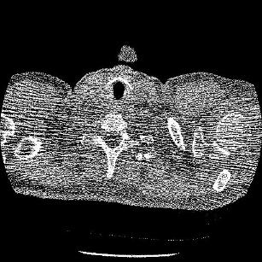 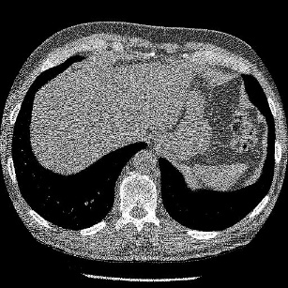 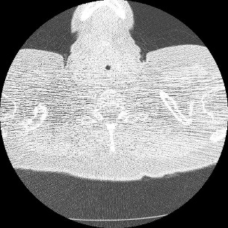 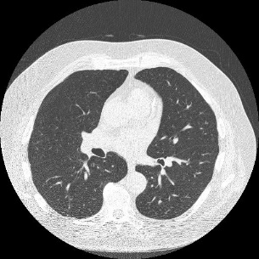

1. **(b) (c) (d)**

Figure 3: Data set of original CT image

The images are corrupted with Gaussian White Noise and the proposed method is applied on them for de-noising. Results are obtained on different noise level ($σ$): 10, 15, 20, 25, 30. In figure 4, the noise level of the CT images is 20.

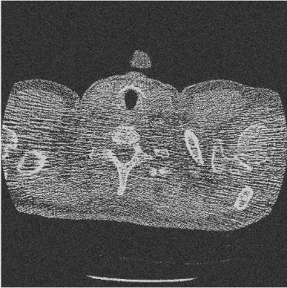 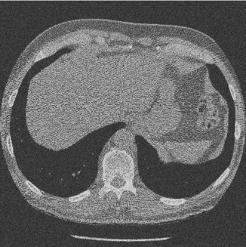 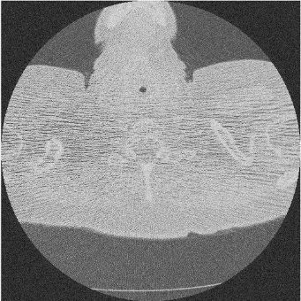 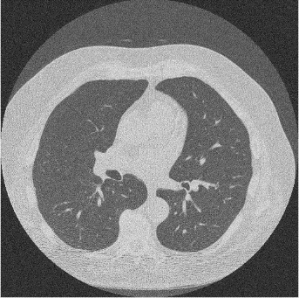

1. **(b)** **(c)** **(d)**

Figure 4: Noisy CT image data set

Figure 5 shows the results of NLM filtering. Contrast between the original image and NLM filtering can be seen in Fig: 6. The images are further processed with method noise to recover the missing parts and reduce the noise. We perform wavelet packet thresholding on the difference images by using circular shifting for finer preservation of the edges and suppressing the noise. Best threshold value can be obtained from the concept of circular shift.

To test the results of the proposed works, the resultant images are compared with some previously existing methods. For comparing, methods used are Dictionary Learning and K-SVD based denoising, Total Variation, image denoising based on NLM filter and its method noise thresholding (NLFMT), SURELET based de-noising, WBBT (Wavelet Based Bivariate Thresholding), wavelet based de-noising using correlation analysis (WBCA), multiresolution Bilateral filter.

Fig 5: shows the result of NLM filter, Fig 7: shows the result of Total Variation, Fig 8: shows the result of Dictionary Learning and K-SVD based denoising, Fig 9: shows the result of NLFMT filtering. Fig 10: shows the result of SURELET based denoising. Sharp and smooth denoised CT images shown in figures 5 and 9 are obtained from NLM and NLFMT methods. It has been observed that as the noise increases, sharp information of the images may get loss. Fig: 7 and 8 shows the result of TV and K-SVD methods respectively. In this texture of the image is not improved but they are good in terms of edge preservation. Fig: 10 shows the results of wavelet based denoising using correlation analysis, wavelet based denoising using multi-resolution Bilateral filter, SURELET and wavelet based bivariate thresholding respectively provided smoothness in homogeneous regions. SURELET and multi-resolution based filtering do not give satisfactory results and fails as the noise level increases. Wavelet based bivariate thresholding method and wavelet based denoising using correlation analysis fails as the noise level in the image increases.

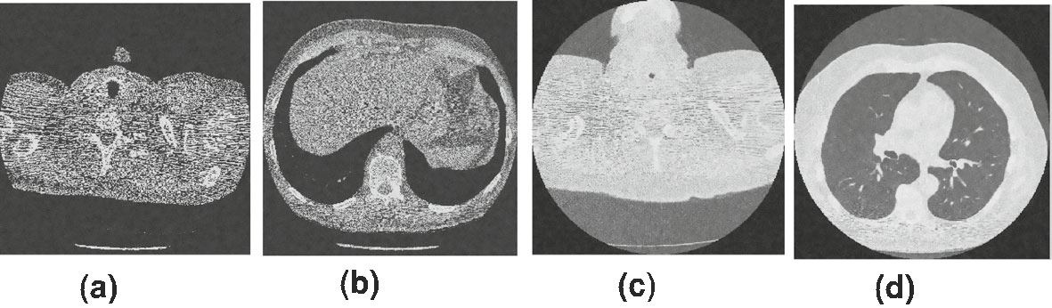

Figure 5: Results of NLM filtering

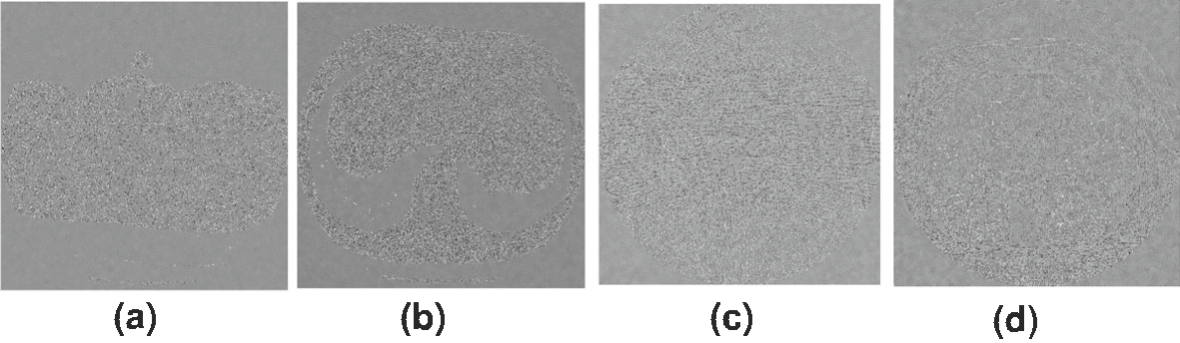

Figure 6: Difference image of difference between original and NLM filtered image

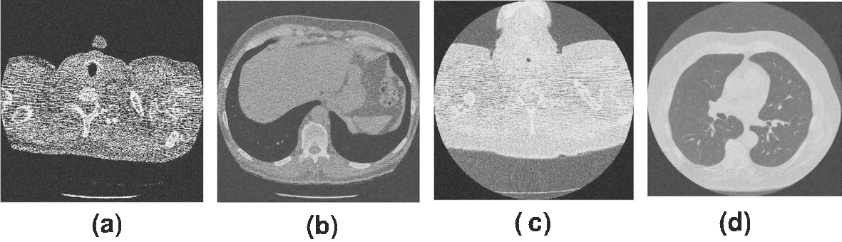

Figure 7: Total Variation Denoising

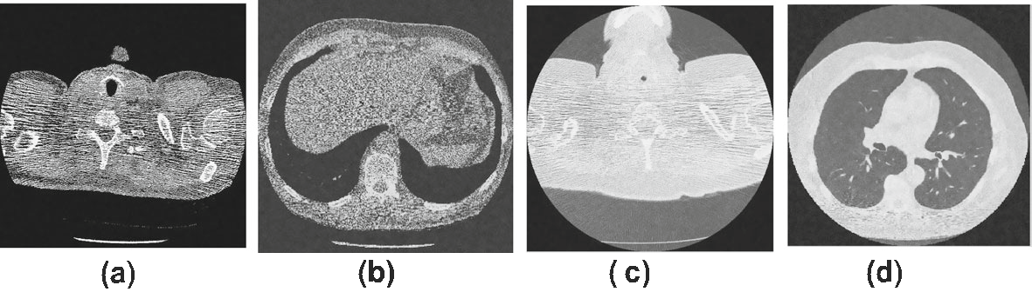

Figure 8: K-SVD Denoising

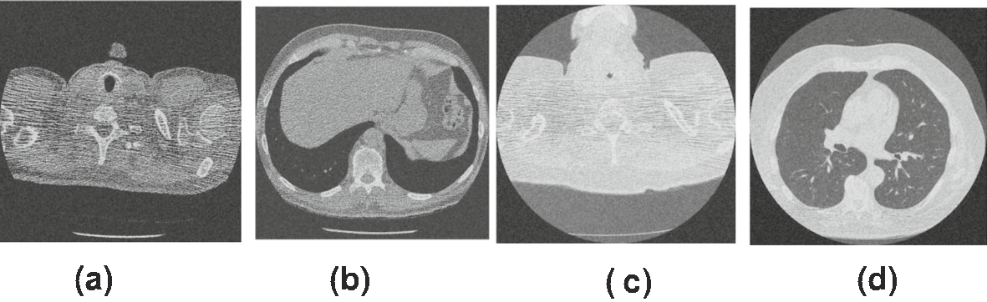

Figure 9: Non local means filter

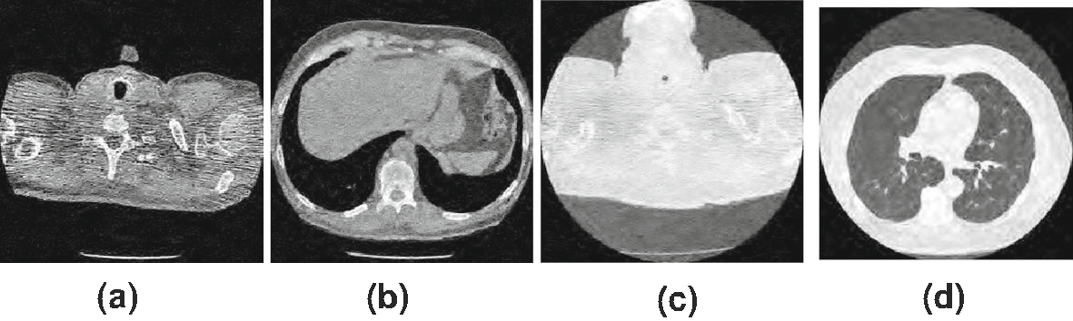

Figure 10: Results of SURELET

The already existing methods and the proposed framework are set side by side with Peak Signal-to-Noise Ratio (PSNR), Structure Similarity (SSIM) index and Entropy Difference (ED).

For input image (I) and obtained denoised CT image (R), above values can be calculated:

**Entropy** can be calculated as follows:

$ED=SE\left(I\right)-SE(R)$

where SE is Shannon Entropy, SE can be calculated as:

$SE= -\sum_{i}{I_{i}^{2}log⁡(I_{i}^{2})}$

**PSNR** is a major factor with the help of which we can recognise the image denoising quality.

PSNR can be expressed as:

$PSNR=10 × \log_{10}\left(\frac{255 ×255}{MSE}\right)$

**Table 1:** PSNR of Noiseless CT images

|  |  |  |  |  |  |  |  |  |  |  |  |
| --- | --- | --- | --- | --- | --- | --- | --- | --- | --- | --- | --- |
| *Σ* | 10 | 15 | 20 | 25 | 30 | 10 | 15 | 20 | 25 | 30 |  |
|  |  |  |  |  |  |  |  |  |  |  |  |
| Input | CT1 | 256×256 |  |  |  | CT2 | 256×256 |  |  |  |  |
| [1] | 31.41 | 31.99 | 28.01 | 28.51 | 26.07 | 32.18 | 28.24 | 29.60 | 27.17 | 25.74 |  |
| [2] | 32.06 | 29.52 | 28.73 | 27.16 | 26.47 | 32.06 | 31.02 | 29.15 | 27.87 | 24.63 |  |
| [3] | 32.21 | 28.84 | 29.24 | 27.29 | 25.55 | 31.11 | 29.92 | 28.18 | 26.91 | 24.39 |  |
| [4] | 33.09 | 31.81 | 29.42 | 27.19 | 25.46 | 31.02 | 29.32 | 27.26 | 26.17 | 24.44 |  |
| [5] | 33.12 | 31.74 | 29.37 | 27.01 | 25.36 | 31.69 | 31.55 | 29.19 | 27.73 | 25.09 |  |
| [6] | 33.11 | 31.44 | 29.02 | 26.14 | 25.92 | 32.15 | 28.43 | 29.01 | 27.42 | 25.47 |  |
| [7] | 33.31 | 31.16 | 29.81 | 26.53 | 26.04 | 31.04 | 31.39 | 29.62 | 27.72 | 25.96 |  |
| [8] | 32.81 | 28.82 | 28.47 | 27.64 | 26.54 | 31.29 | 29.55 | 27.04 | 25.26 | 24.95 |  |
| **Proposed** | **28.88** | **25.27** | **22.66** | **20.63** | **18.92** | **26.55** | **23.08** | **20.52** | **18.66** | **17.02** |  |
| Input | CT3 | 256×256 |  |  |  | CT4 | 256×256 | 29.97 |  |  |  |
| [1] | 31.12 | 31.64 | 29.12 | 27.62 | 25.27 | 32.55 | 28.08 | 27.27 | 25.74 |  |
| [2] | 31.77 | 29.45 | 28.99 | 27.33 | 25.06 | 32.11 | 31.57 | 29.73 | 27.82 | 25.07 |  |
| [3] | 32.93 | 28.53 | 29.33 | 27.43 | 25.03 | 31.17 | 29.82 | 28.03 | 26.42 | 24.74 |  |
| [4] | 33.72 | 31.93 | 29.43 | 27.05 | 25.79 | 31.32 | 29.06 | 27.43 | 26.94 | 24.94 |  |
| [5] | 32.17 | 31.07 | 29.60 | 27.39 | 25.74 | 33.05 | 31.62 | 29.15 | 27.43 | 25.73 |  |
| [6] | 32.13 | 31.04 | 29.83 | 28.13 | 26.57 | 33.05 | 31.75 | 29.14 | 27.93 | 26.24 |  |
| [7] | 31.64 | 31.27 | 29.90 | 27.42 | 26.96 | 33.42 | 31.33 | 29.52 | 27.62 | 25.66 |  |
| [8] | 31.76 | 28.95 | 27.64 | 25.32 | 24.32 | 32.09 | 28.62 | 28.66 | 26.32 | 24.86 |  |
| **Proposed** | **23.33** | **21.65** | **20.67** | **20.02** | **19.46** | **28.47** | **25.89** | **24.28** | **23.34** | **22.78** |  |

**Table 2:** SSIM of Noiseless CT images

|  |  |  |  |  |  |  |  |  |
| --- | --- | --- | --- | --- | --- | --- | --- | --- |
| *Σ* | 10 | 20 | 30 | 40 | 10 | 20 | 30 | 40 |
| Input | CT1 | 256×256 |  |  | CT3 | 256×256 |  |  |
| DTV | 0.7821 | 0.7993 | 0.7078 | 0.6593 | 0.8362 | 0.8953 | 0.7609 | 0.6481 |
| CDTV | 0.7738 | 0.7964 | 0.7076 | 0.6577 | 0.8307 | 0.9898 | 0.7571 | 0.6561 |
| NCTV | 0.7564 | 0.7872 | 0.7024 | 0.6551 | 0.8208 | 0.8777 | 0.7451 | 0.6413 |
| SBTV | 0.7428 | 0.7777 | 0.6984 | 0.6518 | 0.8122 | 0.8703 | 0.7394 | 0.6306 |
| IRTV | 0.7955 | 0.8159 | 0.7134 | 0.6635 | 0.8451 | 0.9026 | 0.7681 | 0.6556 |
| ETV | 0.7878 | 0.8051 | 0.7108 | 0.6609 | 0.8397 | 0.8988 | 0.7654 | 0.6495 |
| **Proposed** | **0.5082** | **0.4894** | **0.4607** | **0.4221** | **0.5981** | **0.4332** | **0.3238** | **0.2561** |
| Input | CT2 | 512×512 |  |  | CT4 | 512×512 |  | 0.7858 |
| DTV | 0.7703 | 0.7650 | 0.6481 | 0.5789 | 0.8386 | 0.7062 | 0.7988 |
| CDTV | 0.7619 | 0.7568 | 0.6469 | 0.5768 | 0.8345 | 0.7022 | 0.7817 | 0.7789 |
| NCTV | 0.7412 | 0.7458 | 0.6596 | 0.5723 | 0.8251 | 0.8927 | 0.7742 | 0.7731 |
| SBTV | 0.7259 | 0.7396 | 0.6344 | 0.5693 | 0.8158 | 0.8823 | 0.7658 | 0.7672 |
| IRTV | 0.7870 | 0.7887 | 0.6569 | 0.5825 | 0.8472 | 0.9152 | 0.7937 | 0.7583 |
| ETV | 0.7775 | 0.7975 | 0.6529 | 0.5799 | 0.8423 | 0.9103 | 0.7887 | 0.7862 |
| **Proposed** | **0.6152** | **0.5592** | **0.4715** | **0.3708** | **0.5919** | **0.3252** | **0.2042** | **0.1557** |
|  |  |  |  |  |  |  |  |  |

Tables 1, 2 represents the tabulated values of PSNR, SSIM and Entropy Difference respectively. Higher the value of PSNR results in higher quality of image and lesser value of ED represents best value. Figure 11 shown below shows the result of proposed work and figure 12 represents the difference between noiseless original image and resultant of proposed scheme. Fig. 6 and 12, when compared it can be noticed that the error in proposed framework is less and provides better structure preservation with reduced noise. Therefore, the proposed framework yields in better results in terms of noise reduction and edge preservations.

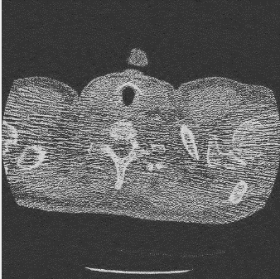 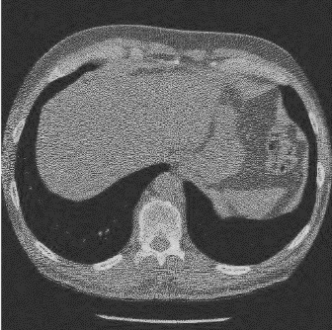 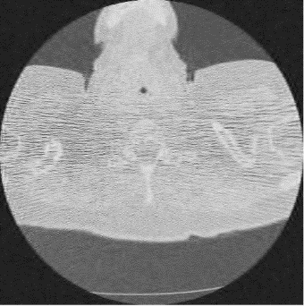 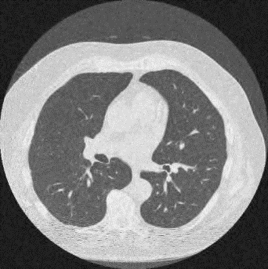

(a) (b) (c) (d)

Figure 11: Outcomes of Proposed Framework

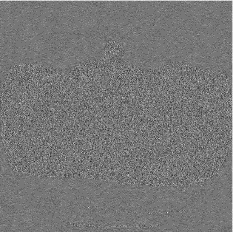 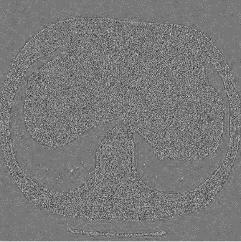 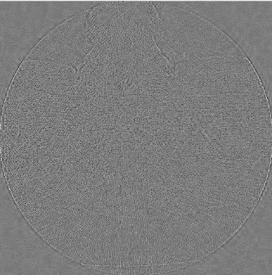 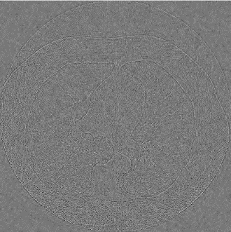

1. (b) (c) (d)

Figure 12: Difference between original image and proposed framework

1. **Conclusion**

In this paper, a new denoising framework based on thresholding and bilateral filter is introduced. Results obtained are great in terms of edge preserving and image denoising. We also compared the non-wavelet techniques and wavelet techniques with the proposed framework. If we compare the results of proposed framework and the existing technique it can be noticed that the outcome of proposed framework is much better. The final results are compared in terms of PSNR and SSIM.

1. **References**
2. Buades A, Coll B, Morel Song JM (2005) A review of image denoising algorithms, with a new one. SIAM J Multiscale Model Simul 4(2):490–530
3. Goldstein T, Osher S (2009) The split bregman method for l1 regularized problems. SIAM J Imaging Sci 2(2):323–34
4. Elad M, Aharon M (2006) Image denoising via sparse and redundant representations over learned dictionaries. IEEE Trans Image Process 15(12):3736–45
5. Shreyamsha Kumar BK (2013) Image denoising based on non-local means filter and its method noise thresholding. Springer J Sig Image Video Process 7(6):1211–1227
6. Mustafa ZA, Kadah YM (2011) Multi resolution bilateral filter for MR image denoising. In: Proceeding on 1st Middle East conference on biomedical engineering (MECBME). Sharjah, pp 180–184
7. Borsdorf A, Raupach R, Flohr T, Hornegger J (2008) Wavelet based noise reduction in CT-images using correlation analysis. IEEE Trans Med Imaging 27(12):1685–1703
8. Rabbani H, Nezafat R, Gazor S (2009) Wavelet-domain medical image denoising using bivariate laplacian mixture model. IEEE Trans Biomed Eng 56(12):2826–2837
9. Thierry B, Florian L (2007) The SURE-LET approach to image denoising. IEEE Trans Image Process 16(11):2778–2786
10. D. J. Brenner and E. J. Hall, ‘‘Computed tomography—An increasing source of radiation exposure,’’ New England J. Med., vol. 357, no. 22, pp. 2277–2284, 2007.
11. J.A. Christner, V.A. Zavaletta,C.D.Eusemann,A.I.Walz-Flannigan,and C.H.McCollough,‘‘DosereductioninhelicalCT:Dynamicallyadjustable z-axisX-raybeamcollimation,’’AJRAmer.J.Roentgenol.,vol.194,no.1, pp. 49–55, 2010.
12. P. Massoumzadeh, S. Don, C. F. Hildebolt, K. T. Bae, and B. R. Whiting, ‘‘Validation of CT dose-reduction simulation,’’ Med. Phys., vol. 36, no. 1, pp. 174–189, 2009.
13. S. Gu, L. Zhang,W.Zuo,andX.Feng,‘‘Weighted nuclear norm minimization with application to image denoising,’’ in Proc. IEEE Conf. Comput. Vis. Pattern Recognit., Jun. 2014, pp. 2862–2869.
14. L. Rudin, S. Osher, and E. Fatemi, “Nonlinear total variation based noiseremovalalgorithms,”Phys.D,vol.60,pp.259-268,1992.
15. K. Dabov, A. Foi, V. Katkovnik, and K. Egiazarian, “Image denoising by sparse 3-D transform-domain collaborative filtering,” IEEE T. IP, vol.16, no.8, pp.2080-2095,2007.
16. L. Li, Z. Chen, and P. Jiao, “Dual-energy CT reconstruction based on dictionary learning and total variation constraint,” in Proc. Nucl. Sci. Symp. Med. Imag. Conf. (NSS/MIC), Nov. 2012, pp. 2358–2361.
17. G.-H. Chen, J. Tang, and S. Leng, “Prior image constrained compressed sensing (PICCS): A method to accurately reconstruct dynamic CT images from highly undersampled projection data sets,” Med. Phys., vol. 35, no. 2, pp. 660–663, 2008.
18. E. Y. Sidky, C.-M. Kao, and X. Pan, “Accurate image reconstruction from few-views and limited-angle data in divergent-beam CT,” J. X-Ray Sci. Technol., vol. 14, no. 2, pp. 119–139, 2006.
19. G. Yu, L. Li, J. Gu, and L. Zhang, “Total variation based iterative image reconstruction,” in Proc. 1st Int. Workshop Comput. Vis. Biomed. Image Appl., 2005, pp. 526–534.
20. J. Tang, B. E. Nett, and G.-H. Chen, “Performance comparison between total variation (TV)-based compressed sensing and statistical iterative reconstruction algorithms,” Phys. Med. Biol., vol. 54, no. 19, pp. 5781–5804, 2009.
21. D. Kang et al., ‘‘Image denoising of low-radiation dose coronary CT angiography by an adaptive block-matching 3D algorithm,’’ in Proc. SPIE Med. Imag., Lake Buena Vista, FL, USA, Mar. 2013, pp. 86692G1–86692G6.
22. Y. Chen et al., ‘‘Improving low-dose abdominal CT images by weighted intensity averaging over large-scale neighbourhoods,’’ Eur. J. Radiol., vol. 80, no. 2, pp. e42–e49, 2011.
23. D. J. Brenner and E. J. Hall, ‘‘Computed tomography—An increasing source of radiation exposure,’’ New England J. Med., vol. 357, no. 22, pp. 2277–2284, 2007.
24. M. Arjovsky, S. Chintala, and L. Bottou. (2017). “Wasserstein GAN.” [Online]. Available: <https://arxiv.org/abs/1701.07875>
25. J. Deng, W. Dong, R. Socher, L.-J. Li, K. Li, and L. Fei-Fei, “ImageNet: A large-scale hierarchical image database,” in Proc. IEEE Conf. Comput. Vis. Pattern Recognit. (CVPR), Jun. 2009, pp. 248–255.